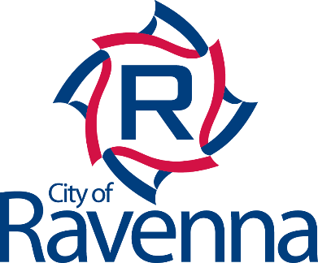 | Backflow Prevention
Backflow is the reverse flow of water from a building’s plumbing back into the public water system. This reversal of flow can be caused by a drop in water pressure downstream of the public system (such as from a water main break or hydrant usage), or an increase of pressure from within the building that is greater than the water supply pressure.

A connection between drinking water pipes and any source of potential contamination is a cross connection. When the water pressure changes from internal usage or water system fluctuations, contaminated water may backflow into your plumbing from unprotected cross connections. Common household cross connections are garden hoses left in chemicals, hoses left in recreational pools, and attachments to hoses used to apply lawn chemicals.

Backsiphonage is a commonly experienced type of backflow. Backsiphonage occurs when the normal direction of flow reverses due to the supply pressure dropping low enough to create a vacuum or negative pressure in the upstream piping. Backsiphonage can be caused by
water main breaks, a break in a customer’s plumbing, when a fire hydrant is struck by a vehicle or abnormally heavy water demand usually from firefighting.

Backflow preventers protect the safety of the public water system by physically preventing the backflow of water and any potential contaminants from the consumer’s plumbing to the public system. The devices are installed by the consumer on their plumbing after the water meter.

The City of Ravenna Public Water System protects the distribution system. One way we do this is by regulating backflow, or potential cross-connections between drinking water pipes and sources of contamination. The customer has the responsibility to ensure there are no cross connections at their home or business and that any installed backflow devices are tested annually.

Backflow preventers are required by the Ohio Environmental Protection Agency (EPA); State law (Ohio Administrative Code 3745-95) and the Ohio Plumbing Code (chapter 608) to be installed where there is a potential health or contamination threat within the consumer’s plumbing system.

To ensure the backflow device is working properly, the consumer is required to have annual testing done by a State certified backflow tester.

The City of Ravenna organizes inspections through Backflow Solutions (BSI Online)
at https://backflow.com

